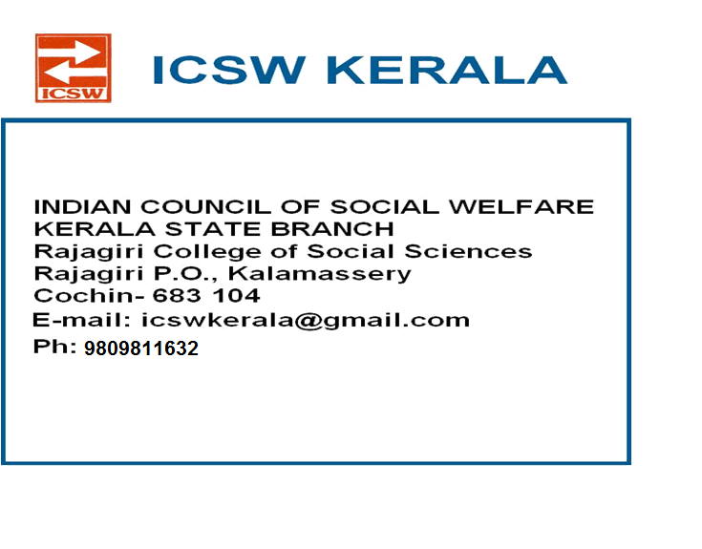

63 years of existence
ANNUAL REPORT 2016-2017

ICSW has been functioning in Kerala since 3rd October 1954 with the State branch office at the campus of Rajagiri College of Social Sciences, Kalamassery, Ernakulam, and District branches in all the 14 districts of Kerala. Justice Krishna Iyer, had been the Founder president of ICSW Kerala.
STATE LEVEL EXECUTIVE COMMITTTE FOR THE YEAR 2015-2017

President | : | Mr. M P Antoni, Ernakulam
Vice Presidents | : | Dr. Asha P. Rao, Thrissur
 |  | Fr. Raju George Thottathil, Malappuram
 |  | Mr. Fabian Prince, Thiruvananthapuram
 |  | Smt. Rosakutty Abraham,Idukki
General Secretary | : | Mr. Deepak G(In-Charge)
Associate Secretary | : | Fr. Jisho Alumkal ,Kottayam
Treasurer | : | Mr. Jacob Thumbayil, Ernakulam

Representatives from all District branches Elected for the year 2015-17

Immediate Past President: Mrs. Beena Sebastian, Ernakulam

Immediate Past Gen Secretary: Mr. Jineshlal R.V

Representative from Patron Members: Fr. Jose Alex CMI, Ernakulam

Representative from Life Members: Dr. Celine Sunny, Ernakulam

Representative from VO/NGO members: Ms. Aisha Salim, Ernakulam

Representative from Institutional member: Fr. Romance Antony, Kottayam

Representative from State Branch
of Associations of Social Work : Dr. Anish K.R., ASSK, Ernakulam

Co-opted members: Dr. Mary Joseph, Ernakulam
Dr. J. Prasant Palakkapillil CMI, Ernakulam
Dr. Cherian. P. Kurien, Idukki
Dr. P. M. Mathew, Kasaragod

MEETINGS HELD / PARTICIPATED

INTERNATIONAL

Dr. Prasant Palakkapillil, Hon. Associate Secretary (south Zone) represented the Indian Council of Social Welfare ,in the ICSW JOINT WORLD CONFERENCE ,2016 on Social Work, Education and Social Development convened by IASSW, ICSW and IFSW took place in Seoul, Republic of Korea on 27-30 June 2016. This Conference brought together practitioners, researchers and educators from around the world who are engaged in Social Work and Social Development.
Dr. Prasant represented our country at the ICSW International General body. Sergei Zelenev ,Executive Director, had personal communication with Prasant to have our National Office to continue with the International membership .

NATIONAL EXECUTIVE COMMITTEE (N.E.C.)

Dr .Prasant Palakkapillil , National Joint Secretary( south Zone) & State Executive member attended the meeting of the National Executive Committee (N.E.C.) of the Indian Council of Social Welfare held on Sunday the 26th March, 2017 at 10.00 am at Bhilai, Chhattisgarh.

STATE EXECUTIVE COMMITTEE MEETING

An Executive Committee Meeting was held on 3rd December 2016 at Rajagiri College of Social Sciences, Kalamassery, Ernakulam. The meeting mainly focused on ICSW Kerala taking up the issues of NGOs as well as that of Social Workers and organize programs for them, so that the visibility of ICSW Kerala will be improved. It was also stated that ICSW Kerala should involve more in the policy matters of the Government.

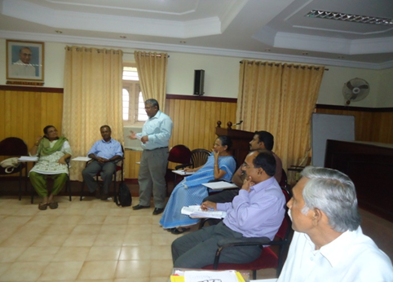

MEMBERSHIP

During the period April 2016 to March 2017, we had enrolled 51 life members .

PETITIONS/REPRESENTATIONS

Include Social Workers while constituting the Benches of Lok Adalat

ICSW Kerala State Branch submitted a petition to Kerala Legal Service Authority (KELSA), High Court of Kerala, to include Social Worker while constituting the Benches of Lok Adalat. As a result, KELSA approved ICSW’s request to include Social Workers and directed ICSW to forward the list of Professional Social Workers in fourteen districts of Kerala. ICSW Kerala State Branch prepared the list and forwarded it to the respective District Legal Authorities during this period.

Renewal of recognition of ICSW as the Scrutinizing agency for Adoption

ICSW Kerala State Branch submitted a request to the Honorable High Court of Kerala (15-07-2016) for the renewal of recognition of ICSW as the scrutinizing agency of In-country and Inter-country adoption. Along with this request, the State office submitted the copies of favorable judgments provided by the Senior Program Officer Mr. Hareendran from the Central Office to support the appeal. As a result of this appeal, the Honorable High Court accepted the request of ICSW Kerala State Branch to act as the Scrutinizing Agency for In-country and Inter-country Adoption before the Family Courts, District Courts and the Juvenile Justice Boards under Juvenile Justice Act in the State by an Order no.D3-72537/2016 dated 22/11/2016.

IN -COUNTRY ADOPTION SCRUTINY CASES

ICSW Kerala State Branch scrutinized seven In-country adoption cases referred by the Honorable Family Court of Trivandrum, during the period April 2016 to March 2017.

N the | INTER-COUNTRY SCRUTINY CASES  ICSW Kerala State Branch scrutinized two Inter-country adoption cases referred by the Honorable Family Court of Trivandrum, during the period April 2016 to March 2017.  PROGRAMMES  One Day Workshop on Juvenile Justice Act 2015 and POCSO Act 2012.  ICSW Members Dr. Mary John - President, Trivandrum Chapter, Mr. Sunny Asariparambil - President, Kannur Chapter, Ms. Aisha Salim - Representative from VO/NGO, Mr. Jobi Babu - Secretary, Idukki Chapter and Mr. Pradul P S - Program Officer, ICSW attended a One Day Workshop on Juvenile Justice Act 2015 and POCSO Act 2012 held on 12th April 2016 at Loyola Extension Services, Trivandrum organized by Kerala Child Rights Observatory (KeCRO) supported by UNICEF.  NACG CHILD LABOUR DAY, JULY 2016  ICSW Kerala joined hands with National Action and Coordination Group for Ending Violence Against Children (NACG EVAC), Kerala to organize the World Day against Child Labour. The focus of the World Day against Child Labour 2016 was “End Child Labour in Supply Chains-It’s everyone’s business”.  Following programmes were held as part of this campaign  1.Pre Consultation Exclusive dialogue with children( below 18yrs) of migrant workers to get a feel of their problems and what is their proposal for the stakeholders of the State at Perumbavoor  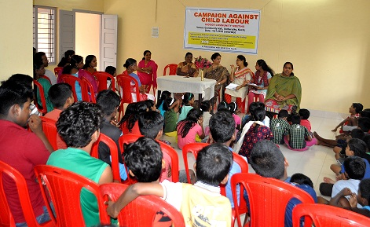  2. Organize an indoor community meeting at Vathuruthy colony, Kochi followed by outdoor community activities  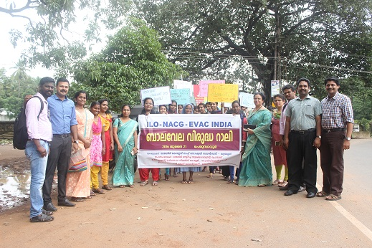  3.One day Stakeholder’s Consultation Meet  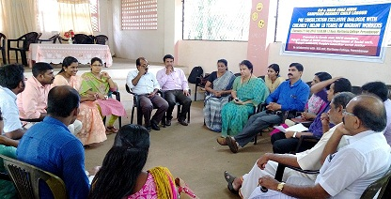  Quiz Competition for Social Work students  ICSW Kerala State Branch organized a Quiz Competition for the BSW students of Rajagiri College of Social Sciences at the Chavara Hall of the College Campus. Three batches of BSW students participated in this event.  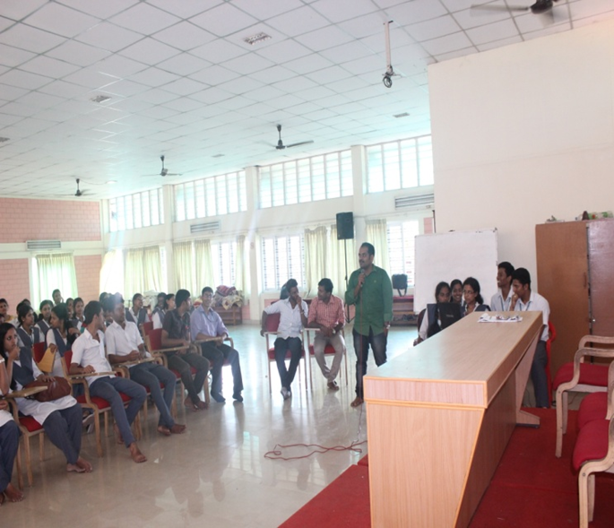

ICSW KERALA –AS A PLATFORM FOR

- NGOs to announce vacancy Notification
- Internship opportunities for professional students
- Verification for Registration of life members who are applying for Social worker’s position in UK, Ireland, Scotland etc,.
- Inter country Case Work reports
- Home study reports for In country adoptions for other State branches

CONCLUSION

The present team gratefully acknowledges the support of the National Team, the various district branches of the state, each of the institutional and individual members, Rajagiri College of Social Sciences, Department of Social Justice, Kerala, High Courts, District Courts & all Family courts in Kerala, all Child Welfare Committees, Association of Schools of Social Work in Kerala (ASSK) and Live Labs in Rajagiri who were abundantly helpful and offered their priceless support. We look forward to continue the great tasks with your enormous and high-quality support.

----------------------------------------------------------

