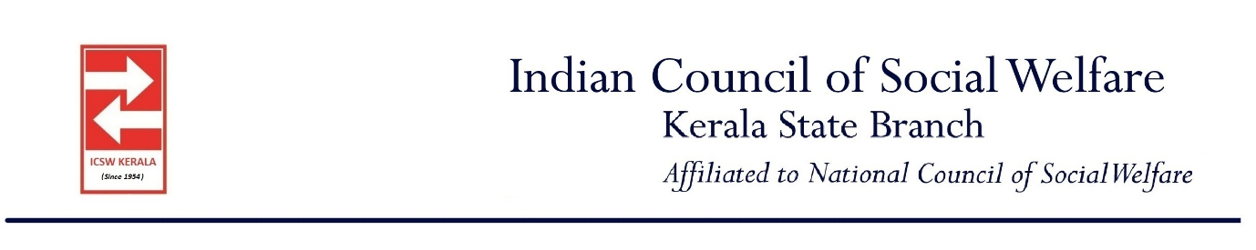

INDIAN COUNCIL OF SOCIAL WELFARE
KERALA STATE BRANCH
Secretariat: Rajagiri College of Social Sciences
Rajagiri PO, Kalamassery, Cochin-683104 Ph.0484- 4111321
Email: icswkerala@gmail.com, Website: icswkerala.in
Annual Report April 2024- March 2025
Indian Council of Social Welfare (ICSW) Kerala State Branch is functional since 3rd October 1954, having its Secretariate in the campus of Rajagiri College of Social Sciences (RCSS), Kalamassery, Ernakulam, with District Branches in all 14 districts of Kerala.
ANNUAL GENERAL BODY MEETING
The Annual General Body Meeting of ICSW Kerala State Branch for the year 2024-25 was conducted on 27th July, 2024 at Rajagiri College of Social Sciences (Autonomous), Kalamassery, Kochi. 25 members were present during the meeting. Dr. Kiran Thampi presented the annual report for the years 2023 to 2024. Mr. Anoop Joseph Joy, Treasurer presented the audited statements for the year 2023 to 2024. The election of new office bearers of ICSW Kerala state branch for the year 2024-2025 was carried out, and Dr. Kiran Thampi was elected as President of ICSW Kerala. The committee decided to renew the registration of the ICSW Kerala chapter for the year 2024-2025.
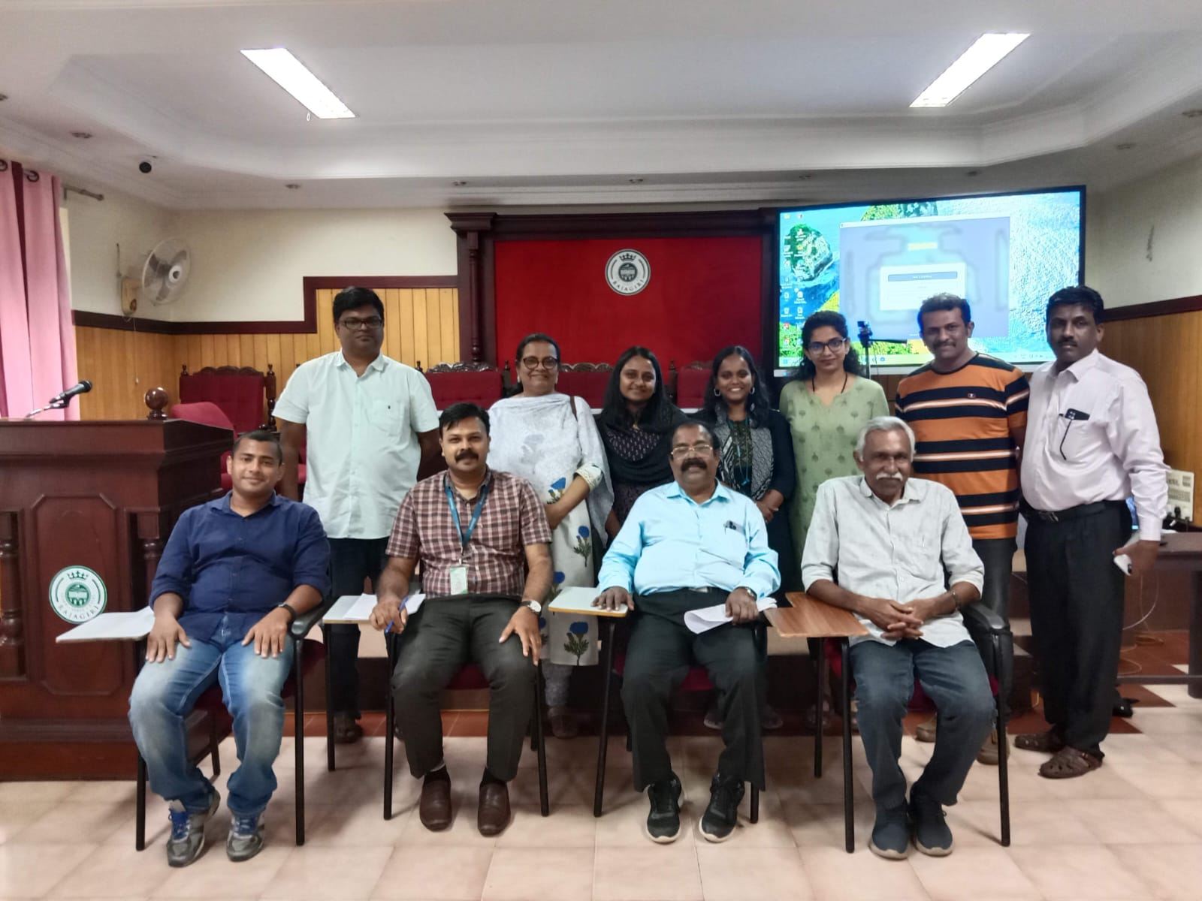
New office bearers 2024-2025
- Dr. Kiran Thampi: President, ICSW Kerala
- Mr. Suresh P: Vice President, ICSW Kerala
- Adv. Mary Cyriac: Vice President, ICSW Kerala
- Mr. P C Jose: Vice President, ICSW Kerala
- Mr. Mary John: Vice President, ICSW Kerala
- Mr. Anoop Joseph Joy: General Secretary, ICSW Kerala
- Mr. Jacob Thumbayil: Treasurer, ICSW Kerala
- Mr. Deepak G: Joint Secretary, ICSW Kerala
Other executive members are
- Smt. Rosakutty Abraham: Executive member
- Mr. Sunny Assariparambil: Executive member
- Mr. C V Antony: Executive member
- Ms. Aisha Salim: Executive member

STATE LEVEL EXECUTIVE COMMITTEE FOR THE YEAR 2024-2025
- Executive Committee Meeting (27.7.2025)

Members Present
- Mr. M N Gunavardhanan IAS (Rtd): President, ICSW Kerala
- Smt. Rosakutty Abraham: Vice President, ICSW Kerala
- Mr. Sunny Asariparambil: Vice President, ICSW Kerala
- Dr. Kiran Thampi: General Secretary, ICSW Kerala
- Mr. Anoop Joseph Joy: Treasurer, ICSW Kerala
- Mr. Deepak G: Joint Secretary, ICSW Kerala
- Mr. Suresh P: District Chapter representative (Thrissur)
- Mr. Aniyan Cherian: Immediate past General Secretary, ICSW

A meeting of the ICSW Executive Committee was held on 27th July, 2024. The Committee’s main focus of the discussion was the revive the membership.

ICSW KERALA STATE-LEVEL ACTIVITIES DURING 2024-2025
- Vikas Samvad (01/08/2024)

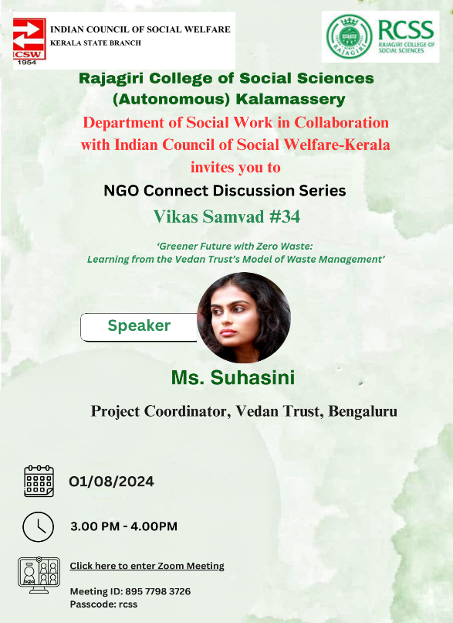
The Department of Social Work, Rajagiri College of Social Sciences (Autonomous), Kalamassery, in collaboration with the Indian Council of Social Welfare, Kerala, organized Vikas Samvad #34, a session under the NGO Connect Discussion Series. The event, titled "Greener future with Zero waste: Learning from the Vedan Trust's model of waste Management," featured Ms. Suhasini – Project Coordinator, Vedan Trust, Bengaluru, as the speaker. The program took place on August 01, 2024, from 3:00 PM to 4:00 PM via Zoom meeting.

- Vikas Samvad (22/08/2024)
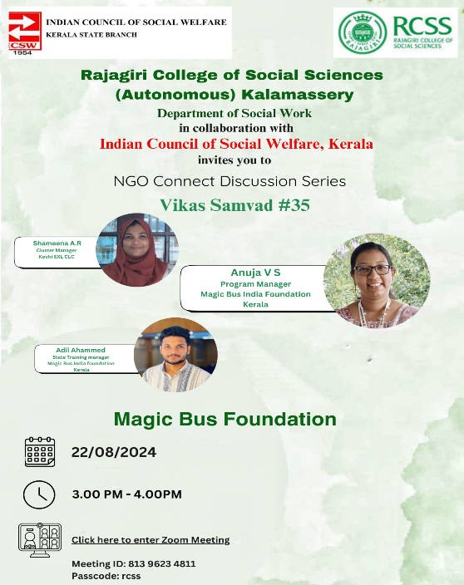
The Department of Social Work, Rajagiri College of Social Sciences (Autonomous), Kalamassery, in collaboration with the Indian Council of Social Welfare, Kerala, organized Vikas Samvad #35, a session under the NGO Connect Discussion Series. The resource Persons are Anuja V S – Program Manager, Magic Bus India Foundation, Shameena A.R – Cluster Manager, Kochi EXL CLC, and Adil Ahammed – State Training Manager, Magic Bus India Foundation, Kerala. The speakers highlighted how the Magic Bus India Foundation uses sports as a tool for building leadership skills among youth in underserved communities

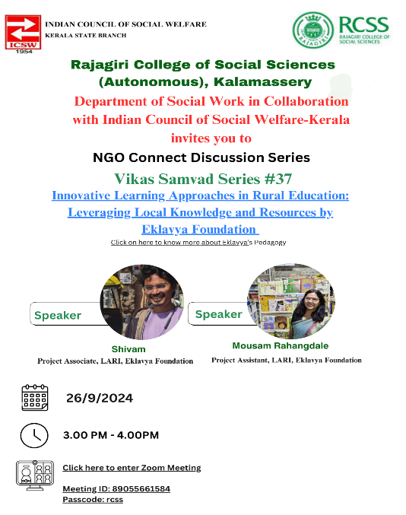
- Vikas Samvad (26/09/2024)

The Rajagiri College of Social Sciences, in collaboration with the Indian Council of Social Welfare-Kerala, hosted the NGO Connect Discussion Series, specifically the Vikas Samvad Series #37. This event focuses on innovative learning approaches in rural education, emphasizing the importance of leveraging local knowledge and resources.

- Vikas Samvad (03/10/2024)
The Social Work Department in collaboration with the Indian Council of Social Welfare-Kerala, organized the 38th Vikas Samvad Discussion Series on October 3, 2024, in honor of World Elderly Day. The session, titled "Understanding Dementia: A Guide for Social Workers," featured Ms. Chippy Sebastian, Clinical Coordinator at DIA, and Ms. Aarthy, Lead of Tele-Dementia Care and Training at NMT, as speakers

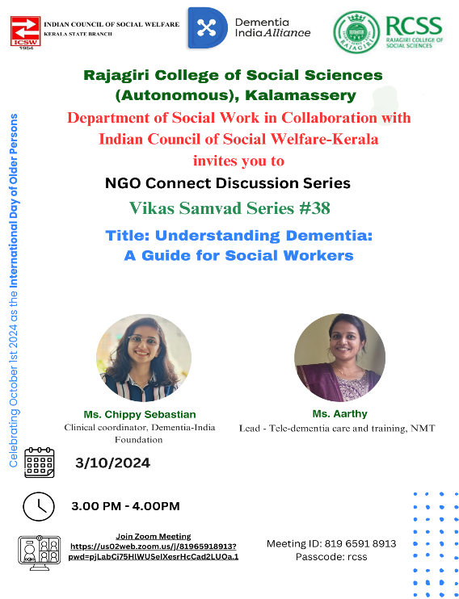
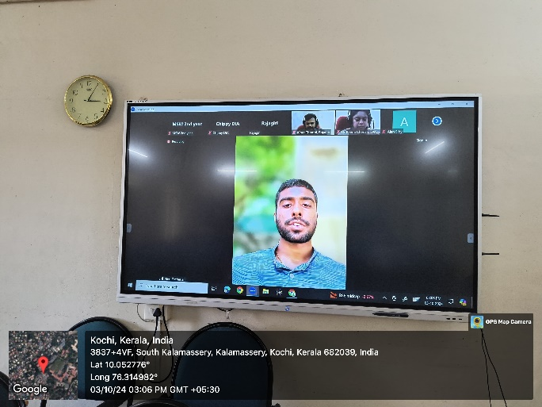
.

- Vikas Samvad (17/10/2024):
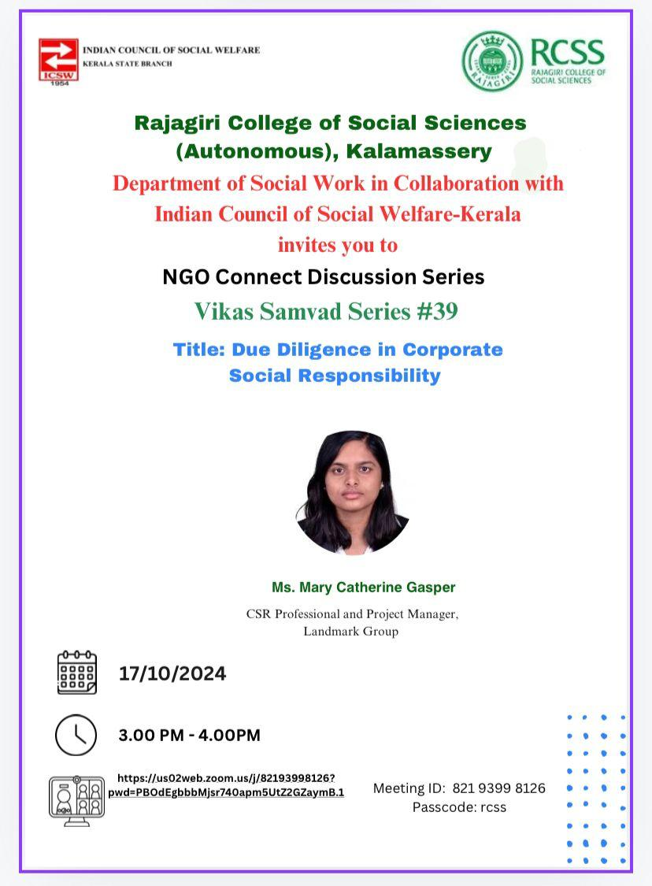
The Social Work Department, in collaboration with the Indian Council of Social Welfare-Kerala, organized the 39th Vikas Samvad Discussion Series on October 17, 2024. The session, titled "Due Diligence in Corporate Social Responsibility," featured Ms. Mary Catherin Gasper, CSR Professional and Project Manager, Landmark Group, as the speaker.

- Vikas Samvad (28/11/2024):

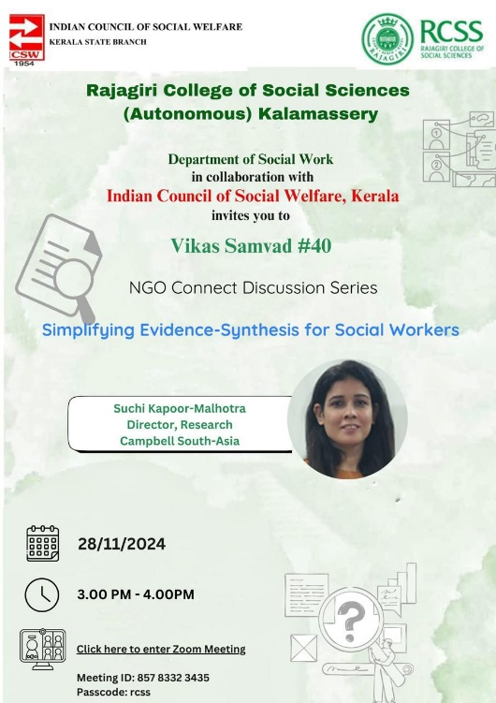
Rajagiri College of Social Sciences (Autonomous), Kalamassery, in collaboration with the Indian Council of Social Welfare, Kerala, organized Vikas Samvad #40, a session under the NGO Connect Discussion Series. The event, titled "Simplifying Evidence-Synthesis for Social Workers," featured Suchi Kapoor-Malhotra, Director of Research at Campbell South-Asia, as the speaker. The program took place on November 28, 2024, from 3:00 PM to 4:00 PM via Zoom meeting.

ICSW MEMBERSHIP CAMPAIGN 2024-2025
Life Membership
During the period from April 2024- March 2025, 22 life members enrolled in ICSW Kerala.

List of life Members registered during April 2024-March 2025

Sl. No. | Name |  | Sl. No. | Name
1 | Thomas P C |  | 12 | Jaise Mol Joy
2 | Mary Amritha K Joseph |  | 13 | Ben Mathew K paul
3 | Blessy Jose |  | 14 | Mariya K Chacko
4 | Sruthy K.V. |  | 15 | Sunitha Sivakumar
5 | Lija Mary Mathew |  | 16 | Bibin Kuriakose Kurikasseril
6 | Ansu C J |  | 17 | Sandra Treesa James
7 | Anoopa. M. Appu |  | 18 | Anu Abraham
8 | Nikhil V |  | 19 | Aparna Ann Thomas
9 | Parvathy V |  | 20 | Ranimol Thomas
10 | Anupam Umesh |  | 21 | Amritha Sreekumar
11 | Asha Surendran Nair |  | 22 | Snehesh. K.D.

VERIFICATION CERTIFICATES TO ICSW LIFE MEMBERS EMPLOYED OUTSIDE THE COUNTRY
Verification certificates were issued to the following life members during the year 2024-2025, who were working at different organisations in the Middle East and European Countries.
1. Mr. Jithin Xavier
2. Ms. Tessy
3. Ms. Mary Amrita K Joseph
4. Ms. Greeshma Sebastian
5. Ms. Asha Mariam Cherian
6. Mr. Saneesh T P
7. Ms. Shilu Mathew
8. Mr. Aneesh Soman

AUDIT STATEMENT OF THE YEAR 2024-25

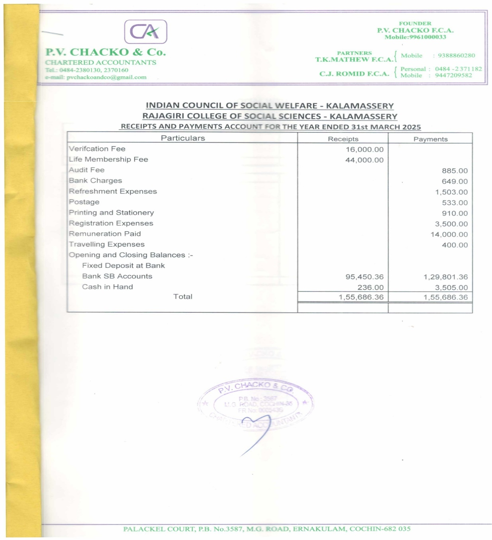

REGISTRATION RENEWAL OF ICSW KERALA FOR THE YEAR 2024 -2025

Registration renewal of ICSW Kerala for the year 2024-2025 was carried out on 12th August 2024.

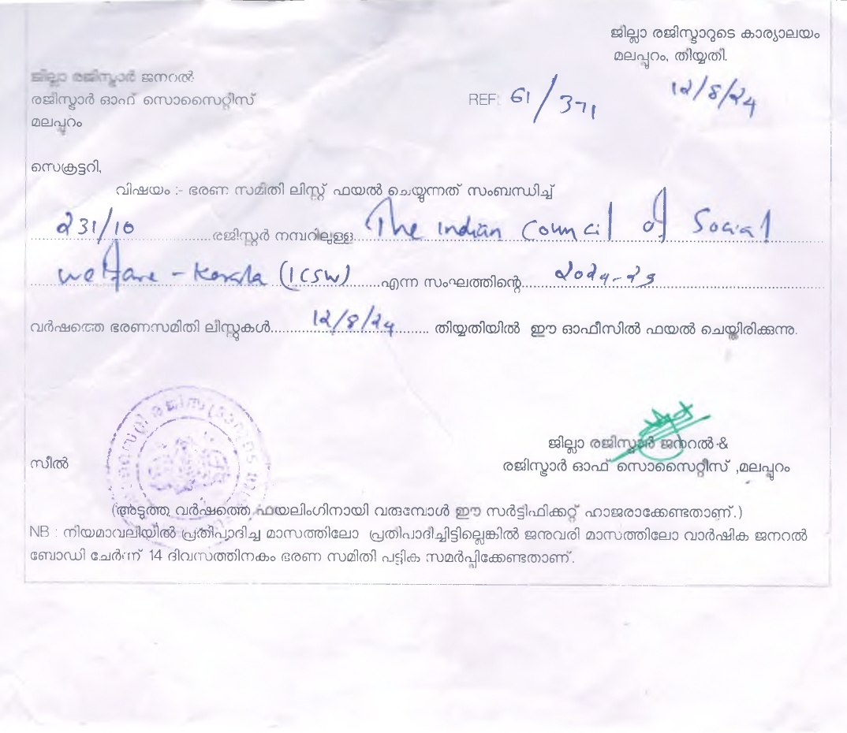

CONCLUSION

ICSW Kerala’s Journey is in its 71st year and happy to acknowledge and appreciate the great support extended by the National Team, various district branches of the state, each institutional and individual members, Rajagiri College of Social Sciences (Autonomous), Association of Schools of Social Work in Kerala (ASSK) and Live Labs at Rajagiri who were greatly helpful and offered their invaluable support during the year 2024-2025. ICSW Team looks forward to continue great tasks with your enormous and excellent support in the days to come.


