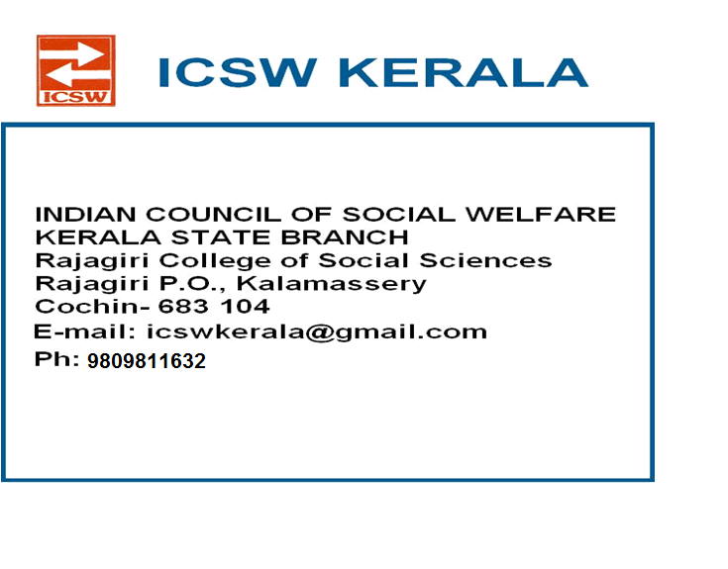

ANNUAL REPORT 2017-2018

ICSW has been functioning in Kerala since 3rd October 1954 with the State branch office at the campus of Rajagiri College of Social Sciences, Kalamassery, Ernakulam, and District branches in all the 14 districts of Kerala. Justice Krishna Iyer, had been the Founder President of ICSW Kerala. ICSW marked its presence in Kerala with:-Networking of NGO’s, Conducting state and national level seminars on topics related to social work , Undertaking scrutiny work of child adoption and Social Work Advancement Program
STATE LEVEL EXECUTIVE COMMITTTE FOR THE YEAR 2017-2019

President : Dr.Mary Venus Joseph
Vice Presidents : Mr. Jineshlal.R.V, Thrissur
Mr. Jacob Thumbayil, Ernakulam
Fr. Romance Antony, Kollam
Smt. Rosakutty Abraham,Idukki
General Secretary : Anoop Joseph Joy, Ernakulam
Associate Secretary : Ms Aisha Salim , Ernakulam
Treasurer : Mr.Santosh.M, Ernakulam

Representatives from all District branches Elected for the year 2017-19

Immediate Past President: M.P.Antoni, Ernakulam

Immediate Past Gen Secretary: Mr. Deepak G, Ernakulam

Representative from Patron Members: Dr V.J.Papoo, Ernakulam

Representative from Life Members: Ms. Neethu Elsa Alexander , Ernakulam

Representative from VO/NGO members: Fr.Varghese Kokadan, Ernakulam

Representative from Institutional member: Dr. J. Prasant Palakkapillil CMI, Ernakulam

Representative from ordinary members: Mr.Unni Krishnan,Kottayam

Representative from State Branch
of Associations of Social Work : Dr.Rajeev S.P, Ernakulam

Co-opted members: Dr. Celine Sunny

Ms.Beena Sebastian ,Ernakulam

Dr. Cherian. P. Kurien, Idukki
Dr.Anitha A, Ernakulam
Kiran Thampi, Ernakulam

MEETINGS HELD / PARTICIPATED

NATIONAL GENERAL BODY MEETING

Dr.Mary Venus Joseph (ICSW Kerala State president) , Dr .Prasant Palakkapillil , (Former National Joint Secretary- south Zone) , Anoop Joseph Joy (ICSW Kerala General Secretary) and Dr Jobi Babu (ICSW Kerala Idukki District Secretary) attended the National General body meeting of the Indian Council of Social Welfare held on Sunday the 24th March, 2018 at 11.30 am at Vashi, Navi Mumbai. Election of Office Bearers for the time period 2018 to 2022 was the main agenda of the meeting. Mr Dineshbhai Rawal was reelected as the President and Mr N.K.Bhupeshbabu Secretary General of the Indian Council of Social Welfare. Narendra Bhai Unadkat was elected as the Treasurer. Other office bearers too were elected. Dr.Mary Venus Joseph was elected as the Vice President of the Indian Council of Social Welfare (south Zone).
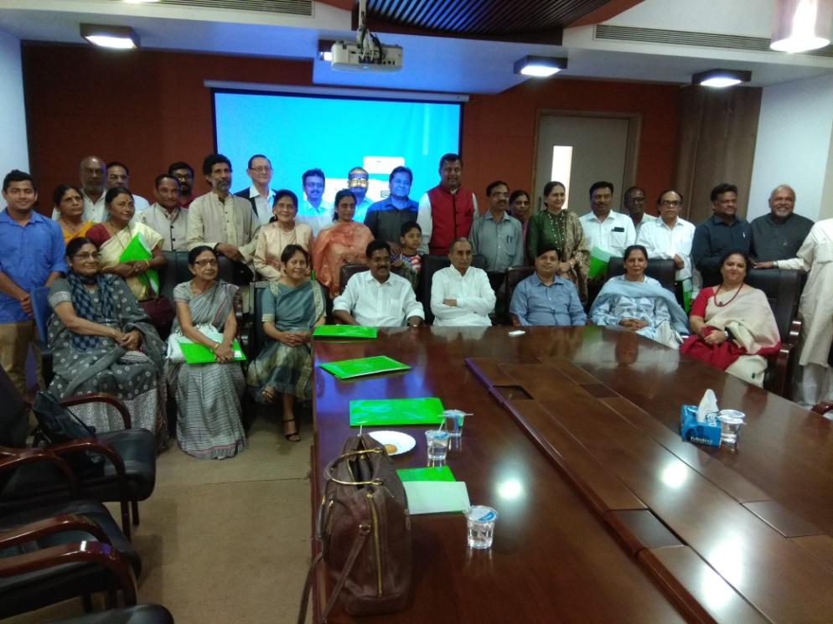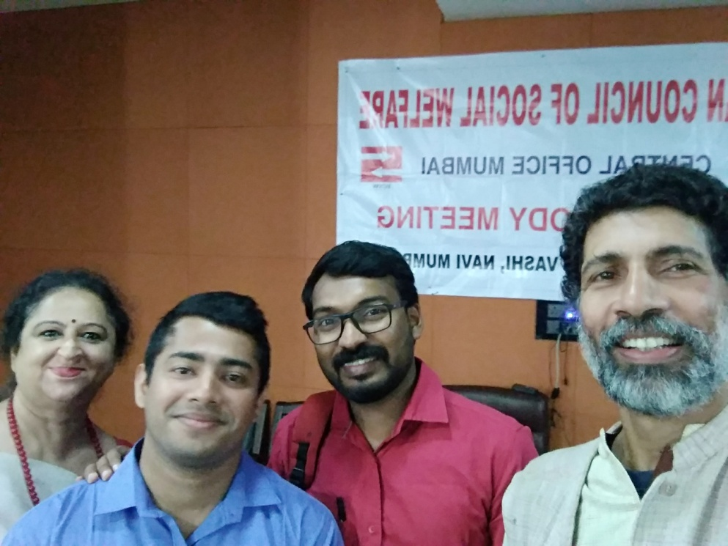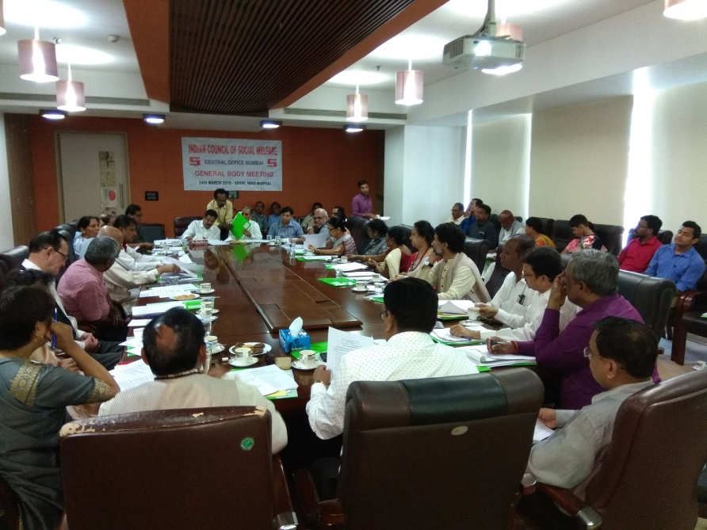

ICSW KERALA MEETINGS

ICSW KERALA SPECIAL MEETING
A special Meeting was held on 25th January 2018 at Rajagiri College of Social Sciences, Kalamassery, Ernakulam from 4.30 p.m to 5.45 p.m. The meeting mainly focused on revival of ICSW Kerala .Mr. M P Antoni, President ICSW Kerala Mr. Deepak G , General Secretary (In Charge) tendered their resignation as they have assumed new office. Mr. Deepak G suggested the name of Dr. Mary Venus Joseph as Acting President ICSW Kerala and Mr. Anoop Joseph Joy as Acting General Secretary, ICSW Kerala till General Body Meeting of ICSW Kerala is held which was acceptable to all the participants.

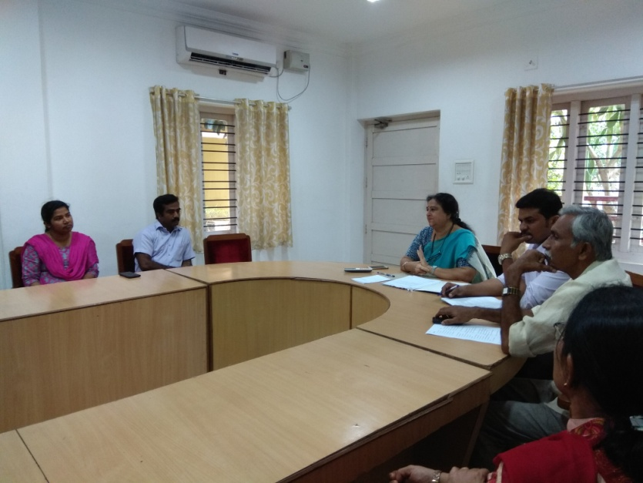

STATE EXECUTIVE COMMITTEE MEETING

An Executive Committee Meeting was held on 17th March 2018 at Rajagiri College of Social Sciences, Kalamassery, Ernakulam) from 4.30 p.m to 5.45 p.m. It was decided at the meeting that Dr.Mary Venus Joseph, to be the Acting President and Mr.Anoop Joy ,to be the Acting General Secretary till the forthcoming AGM. Inorder to revive the activities of ICSW Kerala following two proposals prepared were discussed with executive members Study on Kidney recipients in Kerala-Status and challenges sponsored by K Chittilapilly Foundation and Capacity Building Workshops for NGOs .

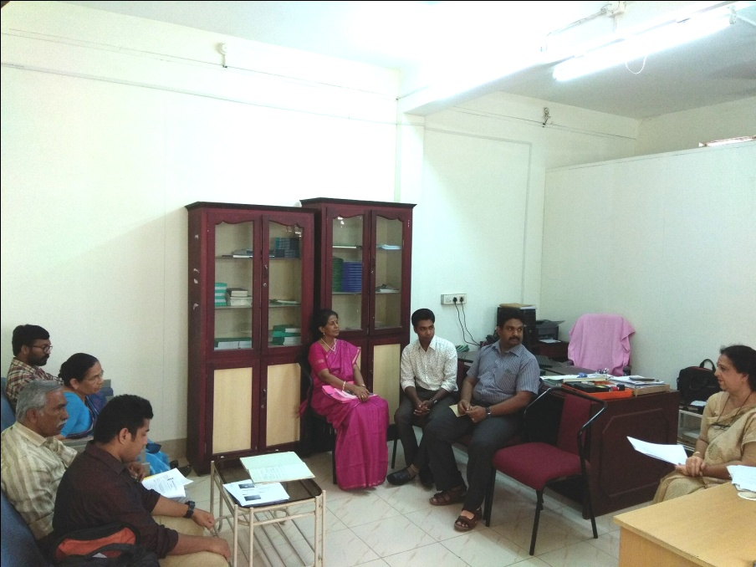

GENERAL BODY MEETING OF ICSW KERALA STATE BRANCH

The General Body meeting of the ICSW Kerala State Branch was held at Rajagiri College of Social Sciences, Kalamassery on Saturday, March 17, 2018.
The meeting started at 11.20 a.m. with a silent prayer. Smt. Rosakutty Abraham, Vice President, ICSW extended a hearty welcome to all the members present. She appreciated all the members for participating in the meeting.
Mary Venus Joseph, President in her presidential address sought the support of all the district chapters to strengthen the functioning of the ICSW Kerala chapter. She also discussed the need to bring more socially committed professionals into the fold of ICSW. A warm welcome was extended to the district representatives from Quilon as well as to Dr. Gunavardhan, Retd IAS and Mr. Suresh, a management consultant who are prospective new members of ICSW. Annual Reports and audited statements for the years 2014-15, 2015-16, & 2016-17 was also read out. Rev. Fr. Prasant Palakkapillil, former National Associate Secretary, ICSW presented a memento to Dr. M.P Antoni to honour him for his services to ICSW over the last three decades. After that election of office bearers of ICSW Kerala for the time period 2017 to 2019 was carried out. Dr.Mary Venus Joseph was elected as the President and Mr.Jineshlal.R.V ,Mr. Jacob Thumbayil, Fr. Romance Antony and Smt. Rosakutty Abraham,Idukki were elected as Vice Presidents. Mr Anoop Joseph Joy was elected as General Secretary and Ms Aisha Salim the Associate Secretary. Mr.Santosh.M was elected as the new Treasurer followed by the election of other members of executive committee.. Mr. Jacob Thumapyil, Vice President, extended the vote of thanks.. The meeting ended at 2.00 p.m. which was followed by lunch.

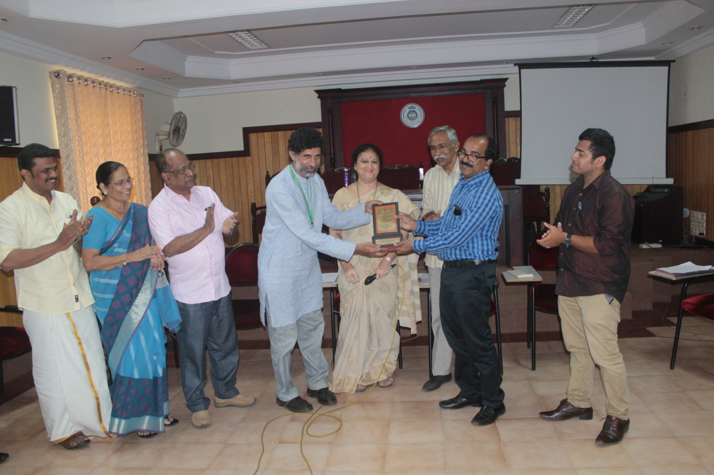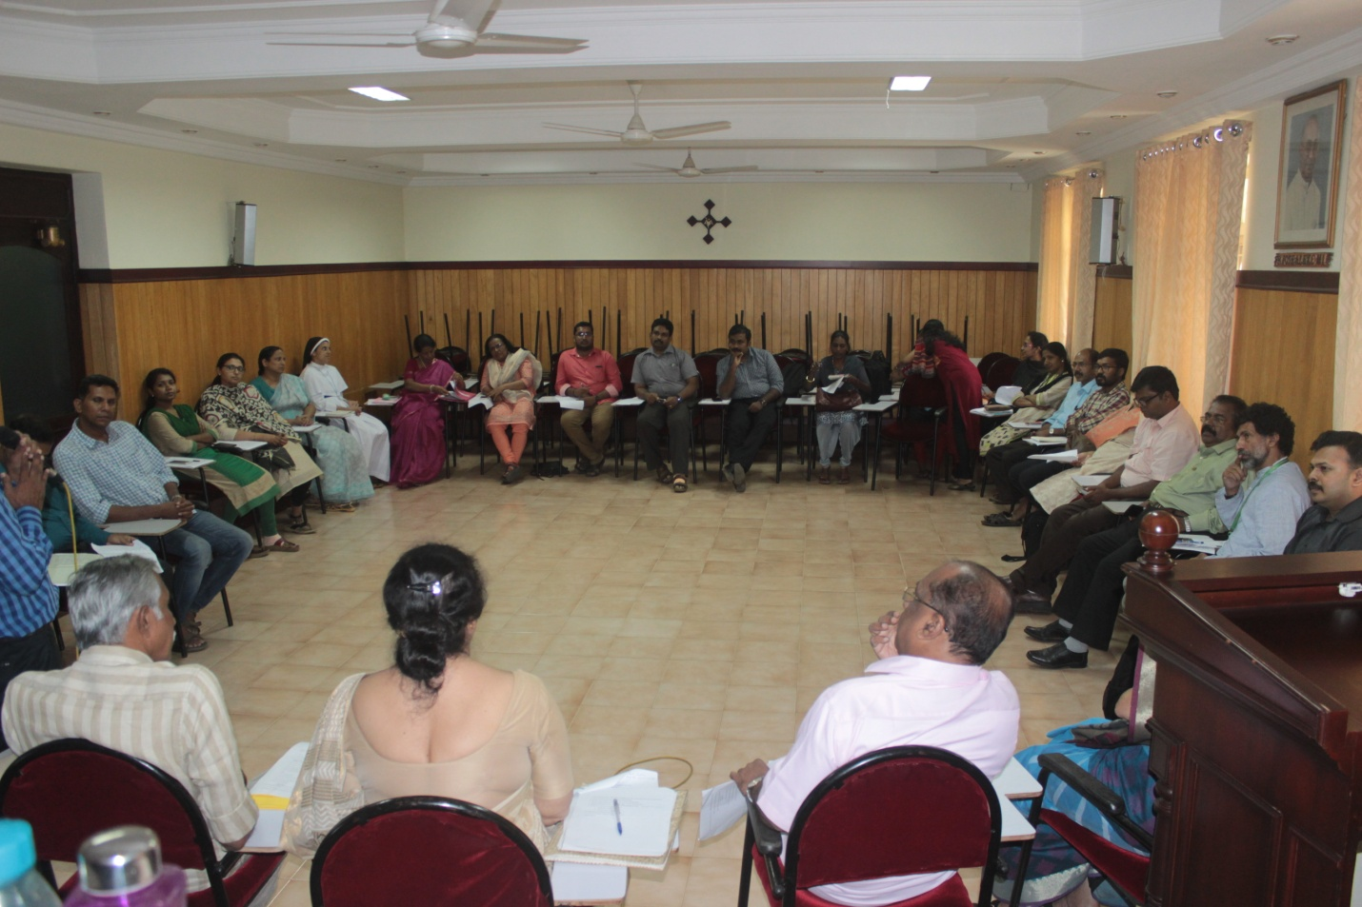

ICSW Kerala State Branch registration renewal

ICSW Kerala State Branch registration renewal documents were submitted to Malapuram registrar office on March 22,2018.

MEMBERSHIP

During the period April 2017 to March 2018, we had enrolled 14 life members.

ICSW KERALA –AS A PLATFORM FOR

- NGOs to announce vacancy Notification
- Internship opportunities for professional students
- Verification for Registration of life members who are applying for Social worker’s position in UK, Ireland, Scotland etc,.

CONCLUSION

ICSW Kerala’s present team in its 64th year of existence is glad to acknowledge the support of the National Team, the various district branches of the state, each of the institutional and individual members, Rajagiri College of Social Sciences, Association of Schools of Social Work in Kerala (ASSK) and Live Labs in Rajagiri who were greatly helpful and offered their invaluable support. We look forward to continue the great tasks with your enormous and excellent support.

----------------------------------------------------------

